Dr. Simon Antony Roberts
10/466 Illawarra Rd
Marrickville South, NSW, 2204
+61-451-830-229
simon@snails.email
Passport: M8747409

Neill Anthony Roberts
41 Amor St, Asquith, NSW, 2077
+61-409-916-460
+61-2-9482-1974
neillr64@gmail.com

25/04/18 09:17:49

To Dearest Neill,

Quite a number of years ago you wrote to us three boys, martin and nathan and I am not sure if they replied but I was thinking about that letter and it came across not only as a then qualified psychologist I didn’t write back and it was suggested in context you could have been experiencing some depression which I know you probably only have supressed at the moment in this highlighted crash you had; which believe it or not in one of my publications for RMIT Masters 2008 in IT, Physics + Psychology which always defers to social when mental health issues arrive, is in a book part of my masters thesis’ – bush rememdies for mental health – an actual cure for depression that is drunk as a tea!

You need to get the bark of acacia obtusifolia which will grow in the surrounding bush of Hornsby Shire, it is thick and chunky unlike all the other barks in acacia and the leaf is slightly smaller than longifolia, you will be able to get a plant diagram stencil from Hornsby Library. What you need to do is get enough bark for around 5 weeks of a cup in the morning starting only in the 1st week, then 2 - 3rd week in the evening as well and for the last two weeks in morning, lunch and dinner, with a plunger you have to drink most of it and let it stew and you can sweeten it if you like and put milk with it. Doesn’t contain any active caffine’s but contains a compound that is water soliable that matches your peutrey gland that controling this state of depression and will regulate this over the 5 week therapy and you will be completely cure permanently of depression and moods and generally be elated to be alive like youthful typal mindset from it in treatment. The only thing you can get for depression in from the pharamacology for depression is placebo only…
Well what is going on with me an iNikk (elpiniki iosif) ~ we he blood test as a man like I blood test as a girl looking human, and my renderments (government) require my martial bonding to be child rearing and I am a lesbain that is a girl that can only have a baby with another girl and that my twin cause I am taboo which iNikk is as well which in male is like get one lady pregnant and the whole postcode that is fertile over a period of a month falls pregnant as young as when things switch on. Well what is in my pants is normally still called a vagina even standing as a guy that a girl standing as a guy, see there are six words which are not of youth, and that is as is men consist of lads + guys and women consist of gals + girls…

Well Elpiniki isn’t really couping with the houso, so I have put in an application for elpiniki to move into community housing and we hope it will be in Hornsby/Asquith, so he can orintate himself again as if we live away from each other for a month or two and not sleep in the same building we will roll over and steph will be back with the name Simon still; with elpiniki back to a boy ~ I was wondering if you could email lorne.hyde@health.nsw.gov.au and just assure him refered to as a her that her will have your support and upmost comforts in your place in Asquith; it will roll under your keyboard when this happens this flip in genetic polymorphism.

See Elpiniki isn’t sick he is having an adverse reaction to the medication like me not having a CYP2*D6 based motablism and is an adult child with the deity temperment of a 7yr old boy, he just turned 7 and can’t take office or position till he is 8yr in cycle which will be a long time.

Anyway I will leave it at that we need to get together to purchase some server space, also I think you should definitely purchase markets.email musicians.email and a couple more for tribes.email..

Best comforts and direction,
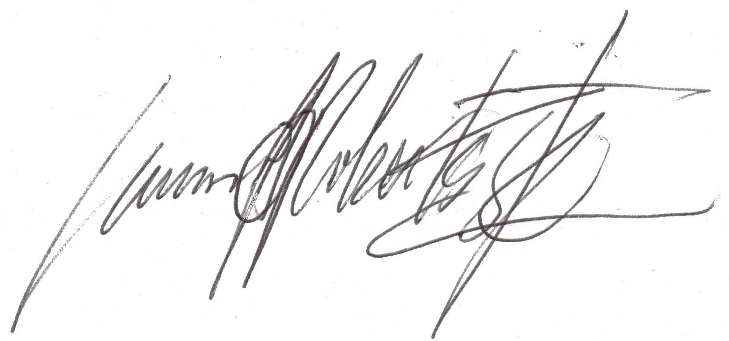

Dr. Simon Antony Roberts
https://twitter.com/SimonXaies
https://facebook.com/mynamesnot
https://internetfounder.wordpress.com

ps. https://internetfounder.wordpress.com/?s=neill

